**CAPSTONE -PROJECT**

**BANK LOAN REPORT – QUERY DOCUMENT**

1. **SUMMARY:**
2. **KPI’S :**
3. **Loan Applications :**

* **Total Loan Applications:**

SELECT COUNT (id) AS TOTAL_LOAN_APPLICATIONS FROM dbo.financial_loan



* **Previous MTD (Month-to-date) Loan Applications :**

SELECT COUNT (id) AS PMTD_TOTAL_LOAN_APPLICATIONS FROM dbo.financial_loan

WHERE MONTH (issue_date) = 8;



1. **Fund Amount:**

* **Total Fund Amount:**

SELECT SUM (loan_amount) AS TOTAL_FUNDED_AMOUNT FROM dbo. financial_loan



* **Current MTD Total Funded Amount:**

SELECT SUM (loan_amount) AS CMTD_TOTAL_FUNDED_AMOUNT FROM dbo.financial_loan

WHERE MONTH (issue_date) = 9 AND YEAR (issue_date) =2021



* **Previous MTD Total Funded(loan) Amount :**

SELECT SUM (loan_amount) AS PMTD_TOTAL_FUNDED_AMOUNT FROM dbo.financial_loan

WHERE MONTH (issue_date) = 8 AND YEAR (issue_date) =2021



______________________________________________________________________________________________-_

1. **Amount Received:**

* **Total Amount Received:**

SELECT SUM (total payment) AS TOTAL_AMOUNT_RECEIVED FROM dbo.financial_loan



* **Current MTD Total Amount Received:**

SELECT SUM (total_payment) AS CMTD_TOTAL_AMOUNT_RECEIVED FROM dbo.financial_loan

WHERE MONTH (issue_date) = 9 AND YEAR (issue_date) =2021



* **Previous MTD Total Amount Received:**

SELECT SUM (total_payment) AS PMTD_TOTAL_AMOUNT_RECEIVED FROM dbo.financial_loan

WHERE MONTH (issue_date) = 8 AND YEAR (issue_date) =2021



1. **Interest Rate:**

* **Average Interest Rate:**

SELECT AVG (int_rate) * 100 AS AVG_INT_RATE FROM dbo.financial_loan



* **Round Off the above average:**

SELECT ROUND (AVG (int_rate),4) * 100 AS AVG_INT_RATE FROM dbo.financial_loan



* **Current MTD Average Interest Rate:**

SELECT ROUND (AVG (int_rate),4) * 100 AS CMTD_AVG_INT_RATE FROM dbo.financial_loan

WHERE MONTH (issue_date) =9 AND YEAR (issue_date) =2021



* **Previous MTD Average Interest Rate:**

SELECT ROUND (AVG (int_rate),4) * 100 AS PMTD_AVG_INT_RATE FROM dbo.financial_loan

WHERE MONTH (issue_date) =8 AND YEAR (issue_date) =2021



______________________________________________________________________________________________

1. **Debt-to-income (DTI):**

* **Average DTI:**

SELECT ROUND (AVG (dti),4) AS AVG_DTI FROM dbo.financial_loan



* **MTD AVG DTI:**

SELECT ROUND (AVG (dti),4) AS CMTD_AVG_DTI FROM dbo.financial_loan

WHERE MONTH (issue_date) =9 AND YEAR (issue_date) =2021



* **Previous MTD AVG DTI:**

SELECT ROUND (AVG (dti),4) *100 AS PMTD_AVG_DTI FROM dbo.financial_loan

WHERE MONTH (issue_date) =8 AND YEAR (issue_date) =2021



__________________________________________________________________________________________

______________________________________________________________________________

1. **GOOD LOAN KPI’s :**

* **Percentage of good loan :**

SELECT

(COUNT (CASE WHEN loan_status ='Fully Paid' OR loan_status='Current' THEN id END) *100)

/

COUNT (id) AS GOOD_LOAN_PERCENTAGE

FROM dbo.financial_loan



* **Applications of good loan**:

SELECT COUNT (id) AS GOOD_LOAN_APPLICATIONS FROM dbo.financial_loan

WHERE loan_status = 'Fully Paid' OR loan_status = 'Current'



* **Good Loan Funded Amount**

SELECT SUM (loan_amount) AS GOOD_LOAN_FUNDED_AMOUNT FROM dbo.financial_loan

WHERE loan_status = 'Fully Paid' OR loan_status = 'Current'



* **Good Loan Amount Received**

SELECT SUM (total_payment) AS GOOD_LOAN_AMOUNT_RECEIVED FROM dbo.financial_loan

WHERE loan_status = 'Fully Paid' OR loan_status = 'Current'



______________________________________________________________________________________________

_______________________________________________________________________________

1. **BAD LOAN ISSUED -> KPI’s:**

* **Percentage of Bad Loan :**

SELECT

    (COUNT (CASE WHEN loan_status = 'Charged Off' THEN id END) * 100.0) /

COUNT (id) AS BAD_LOAN_PERCENTAGE

FROM dbo.financial_loan



* **Applications of bad loan :**

SELECT COUNT (id) AS BAD_LOAN_APPLICATIONS FROM dbo.financial_loan

WHERE loan_status = 'Charged Off'



* **Amount received of bad loan :**

SELECT SUM (total_payment) AS BAD_LOAN_AMOUNT_RECEIVED FROM dbo.financial_loan

WHERE loan_status = 'Charged Off'



_________________________________________________________________________________________

__________________________________________________________________________

1. **LOAN STATUS:**

SELECT

loan_status,

COUNT (id) AS LOAN_COUNT,

SUM (total_payment) AS TOTAL_AMOUNT_RECEIVED,

SUM (loan_amount) AS TOTAL_FUNDED_AMOUNT,

AVG (int_rate * 100) AS INTREST_RATE,

AVG (dti * 100) AS AVG_DTI

FROM dbo.financial_loan

GROUP BY loan_status

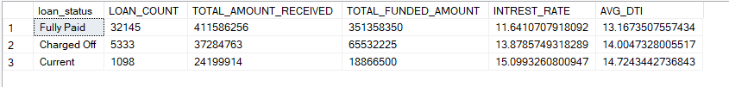

* **Current MTD loan Status:**

SELECT

loan_status,

SUM (total_payment) AS MTD_TOTAL_AMOUNT_RECEIVED,

SUM (loan_amount) AS MTD_TOTAL_FUNDED_AMOUNT

FROM dbo.financial_loan

WHERE MONTH (issue_date) = 9

GROUP BY loan_status

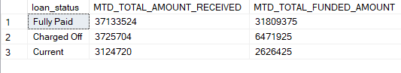

______________________________________________________________________________________________________________________________________________________________________________________________________________

1. **FINANCIAL (BANK) LOAN REPORT | OVERVIEW : (Charts Based)**
2. **MONTH :**

SELECT

MONTH (issue_date) AS MONTH_NUMBER,

DATENAME (MONTH, issue_date) AS MONTH_NAME,

COUNT (id) AS TOTAL_LOAN_APPLICATIONS,

SUM (loan_amount) AS TOTAL_FUNDED_AMOUNT,

SUM (total_payment) AS TOTAL_AMOUNT_RECEIVED

FROM dbo.financial_loan

GROUP BY MONTH (issue_date), DATENAME (MONTH, issue_date)

ORDER BY MONTH (issue_date)

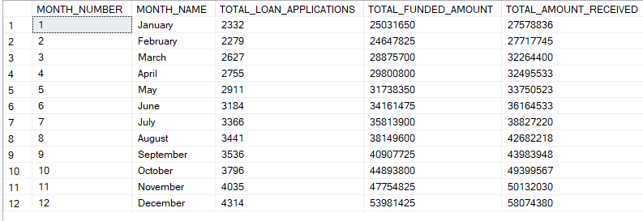

______________________________________________________________________________________________

1. **STATE :**

SELECT

address_state AS STATE,

COUNT (id) AS TOTAL_LOAN_APPLICATIONS,

SUM (loan_amount) AS TOTA_FUNDED_AMOUNT,

SUM (total_payment) AS TOTAL_AMOUNT_RECEIVED

FROM dbo.financial_loan

GROUP BY address_state

ORDER BY address_state

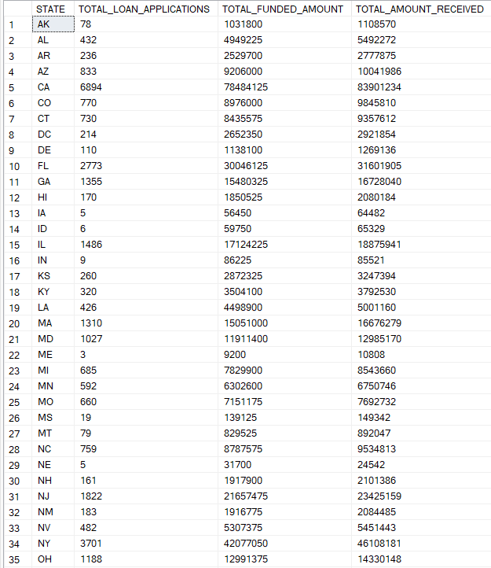

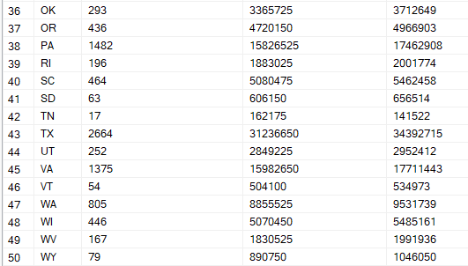

__________________________________________________________________________________

1. **TERM :**

SELECT

term AS Term,

COUNT (id) AS TOTAL_LOAN_APPLICATIONS,

SUM (loan_amount) AS TOTAL_FUNDED_AMOUNT,

SUM (total_payment) AS TOTAL_AMOUNT_RECEIVED

FROM dbo.financial_loan

GROUP BY term

ORDER BY term

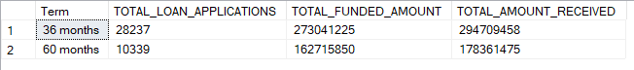

**_______________________________________________________________________________**

1. **EMPLOYEE LENGTH :**

SELECT

emp_length AS EMPLOYEE_LENGTH,

COUNT (id) AS TOTAL_LOAN_APPLICATIONS,

SUM (loan_amount) AS TOTAL_FUNDED_AMOUNT,

SUM (total_payment) AS TOTAL_AMOUNT_RECEIVED

FROM dbo.financial_loan

GROUP BY emp_length

ORDER BY emp_length

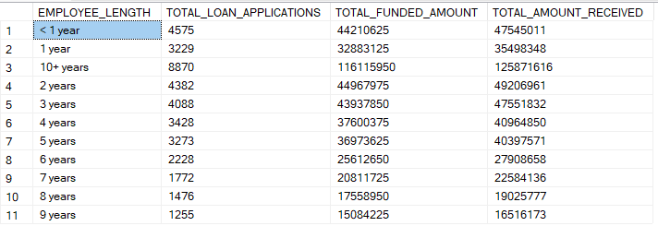

_________________________________________________________________________________

1. **PURPOSE :**

SELECT

purpose AS PURPOSE,

COUNT (id) AS TOTAL_LOAN_APPLICATIONS,

SUM (loan_amount) AS TOTAL_FUNDED_AMOUNT,

SUM (total_payment) AS TOTAL_AMOUNT_RECEIVED

FROM dbo.financial_loan

GROUP BY purpose

ORDER BY purpose

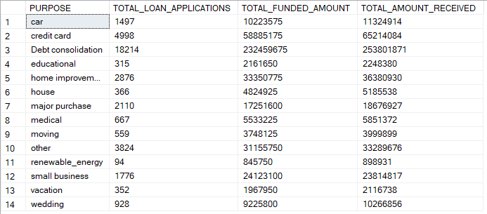

_________________________________________________________________________________

1. **HOME OWNERSHIP :**

SELECT

home_ownership AS HOME_OWNERSHIP,

COUNT (id) AS TOTAL_LOAN_APPLICATIONS,

SUM (loan_amount) AS TOTAL_FUNDED_AMOUNT,

SUM (total_payment) AS TOTAL_AMOUNT_RECEIVED

FROM dbo.financial_loan

GROUP BY home_ownership

ORDER BY home_ownership

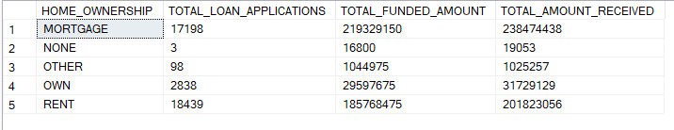

_____________________________________________________________________________________________

**NOTE :**  *I have applied multiple Filters on all the dashboards. You can check the results for the filters as well by modifying the query and comparing the results.*

*For e.g :*

*See the results when we hit the Grade A in the filters for dashboards.*

*SELECT*

*purpose AS PURPOSE,*

*COUNT (id) AS* TOTAL_LOAN_APPLICATIONS*,*

*SUM (loan_amount) AS* TOTAL_FUNDED_AMOUNT*,*

*SUM (total_payment) AS* TOTAL_AMOUNT_RECEIVED

*FROM* dbo.financial_loan

*WHERE grade = 'A'*

*GROUP BY purpose*

*ORDER BY purpose*

**______________________________________________________________________**

**c) Advance SQL QUERIES :**

**1. CTE (Common Table Expressions) :**

**Q-1 : Find average annual income for each home ownership type . :**

WITH CTE_INCOME AS (

SELECT home_ownership, AVG (annual_income) AS avg_income

FROM dbo.financial_loan

GROUP BY home_ownership

)

SELECT * FROM IncomeCTE;

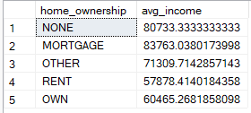

**Q-2: Find top 3 highest loan amounts for each grade. :**

WITH CTE_RankedLoans AS (

SELECT grade, loan_amount,

ROW_NUMBER () OVER(PARTITION BY grade ORDER BY loan_amount DESC) AS rn

FROM dbo.financial_loan

)

SELECT * FROM CTE_RankedLoans WHERE rn <= 3;

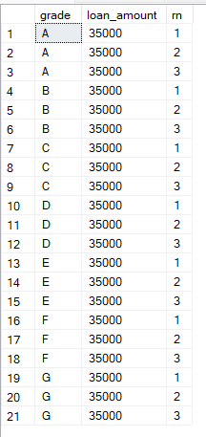

**Q-3: Show loan status distribution (count of each status).:**

WITH LoanStatus AS (

SELECT loan_status, COUNT (*) AS cnt

FROM dbo.financial_loan

GROUP BY loan_status

)

SELECT * FROM LoanStatus;

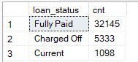

**2. Subqueries:**

**Q-4: Find all borrowers who earn more than the average income.**

SELECT id, emp_title, annual_income

FROM dbo.financial_loan

WHERE annual_income > (SELECT AVG (annual_income) FROM dbo.financial_loan);

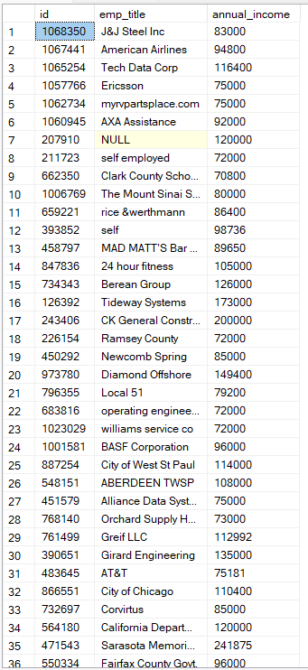

**Q-5: Find states where total loan issued is above the overall average loan issued per state.**

SELECT address_state, SUM (loan_amount) AS total_state_loan

FROM dbo.financial_loan

GROUP BY address_state

HAVING SUM (loan_amount) > (

SELECT AVG (state_total)

FROM (

SELECT SUM (loan_amount) AS state_total

FROM dbo.financial_loan

GROUP BY address_state

) t

);

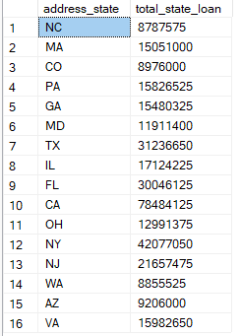

**3. WINDOW FUNCTIONS:**

**Q-6: Rank borrowers by loan amount within each grade. :**

SELECT id, grade, loan_amount,

RANK () OVER (PARTITION BY grade ORDER BY loan_amount DESC) AS loan_rank

FROM dbo.financial_loan;

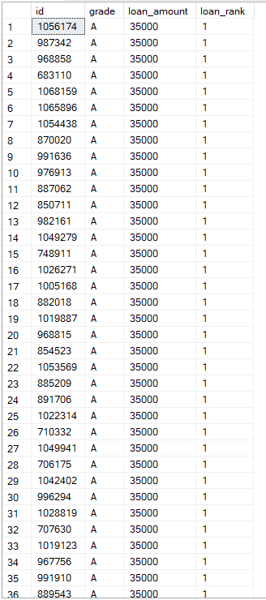

**Q-7 : Show the previous loan amount (LAG) and next loan amount (LEAD) for each borrower ordered by issue_date. :**

SELECT id, loan_amount, issue_date,

LAG (loan_amount) OVER (ORDER BY issue_date) AS prev_loan,

LEAD (loan_amount) OVER (ORDER BY issue_date) AS next_loan

FROM dbo.financial_loan;

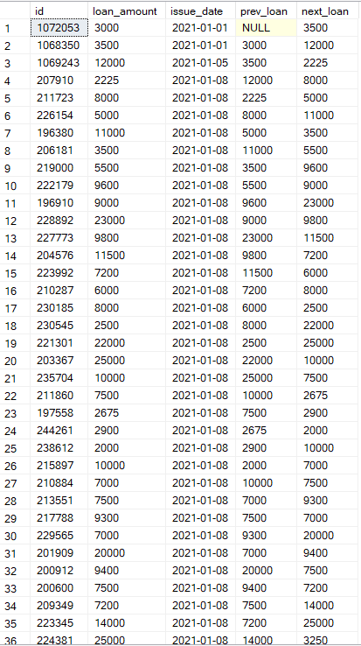

**Q-8: Find cumulative (running) loan amount disbursed by issue_date. :**

SELECT issue_date, loan_amount,

SUM (loan_amount) OVER (ORDER BY issue_date) AS cumulative_loan

FROM dbo.financial_loan;

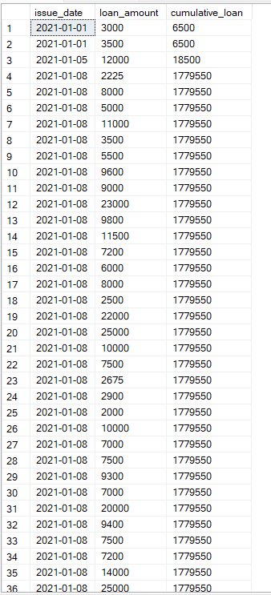

**Q-9: For each state, find borrower with the highest annual income.**

SELECT id, address_state, annual_income

FROM (

SELECT id, address_state, annual_income,

ROW_NUMBER() OVER(PARTITION BY address_state ORDER BY annual_income DESC) AS rn

FROM dbo.financial_loan

) t

WHERE rn = 1;

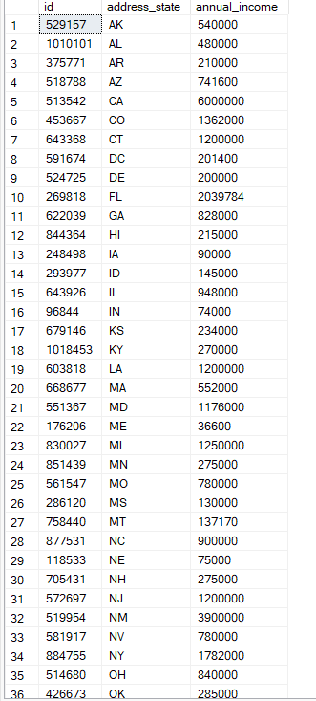

**4. AGGREGATES (GROUP BY, HAVING)**

**Q-10 : Find average interest rate and loan amount by grade.**

SELECT grade, AVG (int_rate) AS avg_rate, AVG (loan_amount) AS avg_loan

FROM dbo.financial_loan

GROUP BY grade;

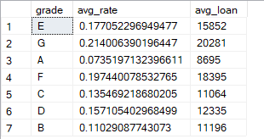

**Q-11: Find the top 5 purposes with highest total loan issued. :**

SELECT TOP 5 purpose, SUM (loan_amount) AS total_loans

FROM dbo.financial_loan

GROUP BY purpose

ORDER BY total_loans DESC;

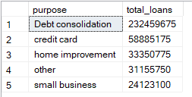

**Q-12: Find states where the average annual income is greater than ₹80,000. :**

SELECT address_state, AVG (annual_income) AS avg_income

FROM dbo.financial_loan

GROUP BY address_state

HAVING AVG (annual_income) > 80000;



1. **CTAS (Create Table As Select) :**

**Q-13 :** **Create a table of all loans that are charged off.**

SELECT *

INTO charged_off_loans

FROM dbo.financial_loan

WHERE loan_status = 'Charged Off';

EXEC sp_help charged_off_loans;

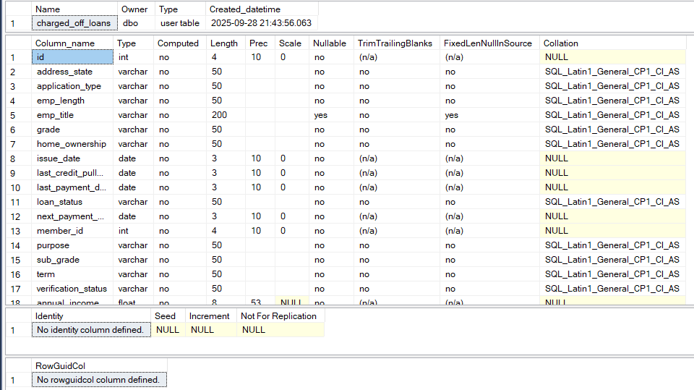

**Q- 14 : Create a table of top 10 borrowers by loan amount.**

SELECT TOP 10 id, emp_title, annual_income, loan_amount, grade, loan_status

INTO top_10_borrowers

FROM dbo.financial_loan

ORDER BY loan_amount DESC;

SELECT * FROM top_10_borrowers;

